**Calculator Project**

Now that you have practiced accessing and manipulating the DOM elements and studied about mouse events and keyboard events. Let's make a calculator to perform some simple algebraic operations.

The symbols/operands have the same meaning as in Mathematics. On hover, highlight the number/operation.

Get started with this assignment and once completed you will enjoy the feeling of finishing your first Javascript Project!

**Below is the image of the calculator, that you are supposed to make -**

[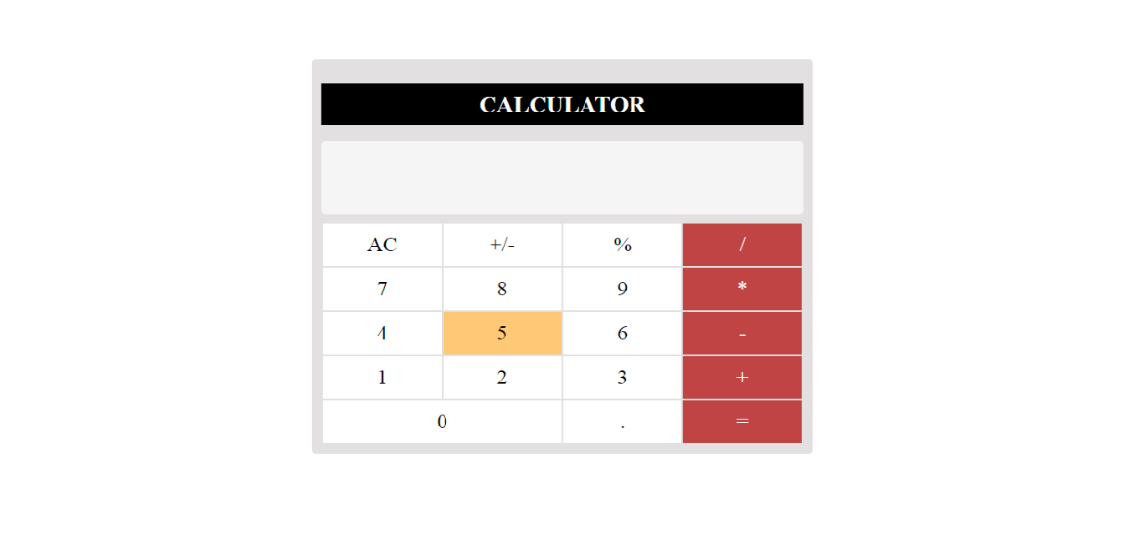](https://ninjasfiles.s3.amazonaws.com/0000000000001857.png)

Once you done with basics, here are couple of additional features that you can work on -

1. Handle Keyboard events i.e. type 1 + 3 to add 1 and 3 and so on.

2. You can also add more operations to your calculator. Check out a scientific calculator!